|  |
| --- |
| Wingtek notions |
| November 30, 2023 |
|  |

# Overview

## What is WingTek Notions???

|  |  |
| --- | --- |
| Badge Tick1 with solid fill | WingTek Notions is all about getting knitters together. The website’s audience is knitters of all skill levels. It is a place where you can store your knitting inventory. These are items like your knitting needles, yarns, books, patterns, projects, etc. It will interface with Ravelry ([www.ravelry.com](http://www.ravelry.com)) another great resource for knitters in that it provides millions of patterns (free and for sale) of patterns. This can be sometimes overwhelming. WingTek Notions plans to provide you inspirations based on your inventory of notions. We can do this daily, weekly, monthly, even yearly!!! We will take your inventory and do the searching for you (using Ravelry’s vast supply of patterns) and get you inspired to knit with your current notions!!!  Eventually we would like to provide a space where you can connect with your friends and knit your inspirations together.  Happy Knitting!!! |

## How will your Project Benefit from React

|  |  |
| --- | --- |
| Badge Tick1 with solid fill | Speed – Who wants a slow experience.  Flexibility – I want to be able to adjust quickly to new demands (requirements)  Performance – I want a lot of users, there are millions of patterns to crawl, and again who wants a slow experience  Usability – Want the experience intuitive for all skill levels  Reusability – Don’t want to re-invent the wheel  Mobile app development – Want the application to be available for all devices |

# What the MVP of your Project will Look Like

## Home Page

## These images are from the pure JavaScript portfolio and will serve as a guide to the React portfolio project

## Navigation Bar with routes

## My Lists (scarfs, hats, and cowls)

## My Notions – under construction

## About Page

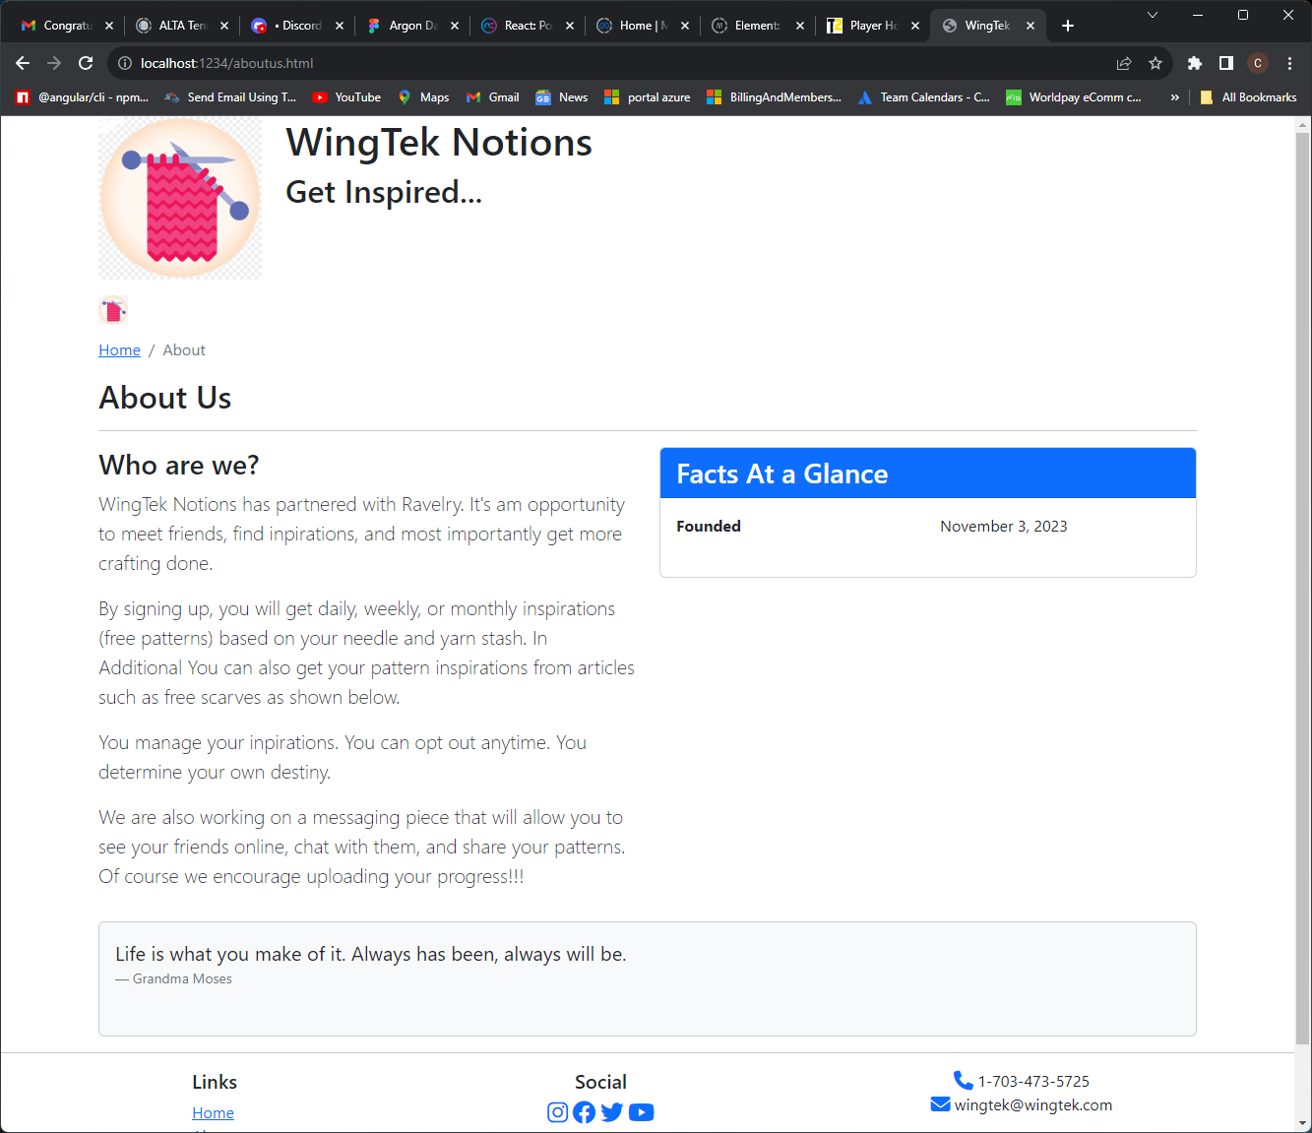

## Registration Page

## Login Page

# What the Project will Look Like in the Future

## Users will have the ability to store inventory such as needles, notions, patterns, projects, and yarn stash.

## Users will be able to create groups for Friends

## Users will be able to join groups for Knit-Alongs

## Users will be able to view videos

# Components

## NavBar

## Footer

## Login Page

## Home Page

|  |  |
| --- | --- |
|  |  |